# **CONVOLUTION NEURAL NETWORKS REPORT**

GLORIA STEPHEN MSBA 64061

Objective:

Comprehensive analysis of CNN to image data.

Observations:

The Convolving networks work better as the sample size increases and use the right techniques for reducing the overfitting of the data while improving the performance by biasing weights and dropping out unwanted units.

Processing of the CNN:

There are 25,000 photos of dogs and cats in the Cats-vs-Dogs dataset, with 12,500 from each set. This will result in the construction of a new dataset that has a training set with 1000 samples of each class, a validation set with 500 samples of each class, and a test set with 500 samples of each class.

The input pictures are originally 200*200 pixels, which causes the feature maps to shrink in size until they've reached 10*10 until they reach the basic dimensioned lined layer. This input size is adequate for the circumstance at hand.

1. Initially downloading the large dataset of the dogs and cars from Kaggle
2. Comprehending the convolution strides & Segregating the validation, train and test samples.
3. Training the convent to evaluate from scratch and implementing through classification instances.
4. Instantiating the classification using the maxpooling operation.
5. Configuring the model for training with the mentioned parameters.

Here I will showcase the tabular and graphical visual of the loss and accuracy and in words mention the operations used and how they effected the evaulation of the data for that particular analysis.

1. Initially analysis of the dataset with the mentioned parametes:

|  |  |  |  |  |
| --- | --- | --- | --- | --- |
| Implementations | Loss | Accuracy | Validation_L | Validation_A |
| Training phase | 93 | 96 | 136 | 62 |
| Data augmentation | 59 | 69 | 68 | 62 |
| Dropout | 27 | 90 | 91 | 65 |
| Both | 64 | 68 | 62 | 64 |

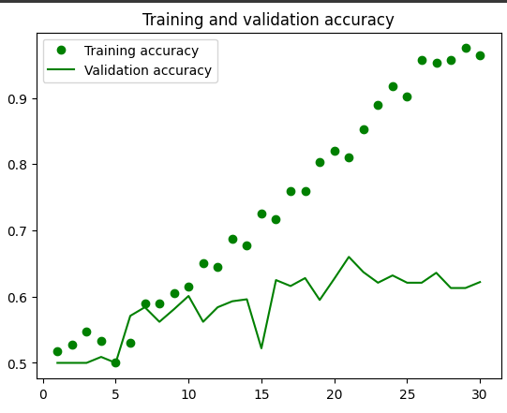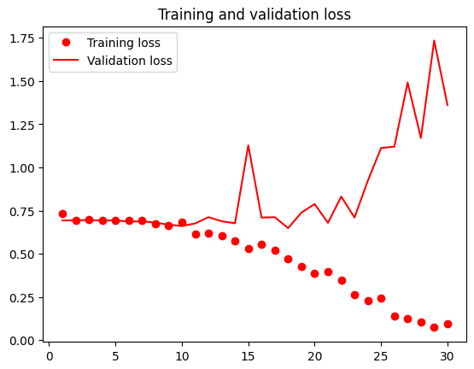

*Test accuracy = 65%*

Data augmentation is a strategy for increasing the amount and variety of a dataset by producing new samples by flipping, rotating, or scaling the current data. Supplying more diverse training data, this improves the performance of machine learning algorithms.

Dropout is a regularization approach in convolutional neural networks that randomly sets a percentage of the neurons to zero during training to minimize overfitting.

On using both the techniques we observe that the output is benefitted by being eliminated by the overfitting data units. Hence providing a better output value and accuracy also witnessed in the graph as the epoch levels increase so does our evaluation get modified.

1. Increasing maxpooling method also Data augmentation Dropout:

|  |  |  |  |  |
| --- | --- | --- | --- | --- |
| Implementations | Loss | Accuracy | Validation_L | Validation_A |
| Increasing maxpooling along with DA and DO | 08 | 97 | 02 | 99 |

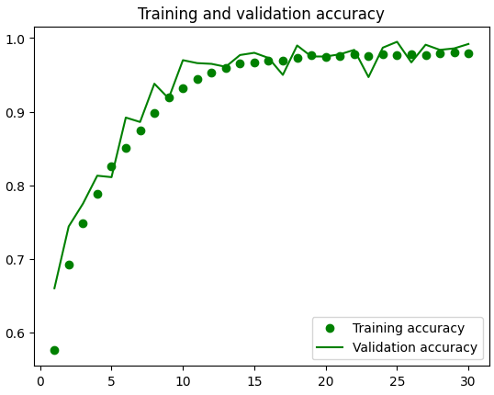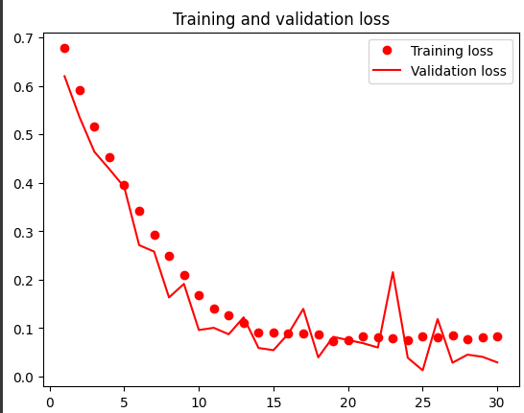

*Test accuracy = 88%*

Maxpooling is a down sampling the system used in convolutional neural networks aimed at reducing the spatial dimensions of feature maps, whereas data augmentation and dropout are regularization mechanisms used to avoid overfitting. By combining the tactics, the model may learn robuster characteristics and extrapolate more accurately to new data.

1. Training model 12000

|  |  |  |  |  |
| --- | --- | --- | --- | --- |
| Implementations | Loss | Accuracy | Validation_L | Validation_A |
| Training model  to 12000 | 12 | 96 | 49 | 90 |

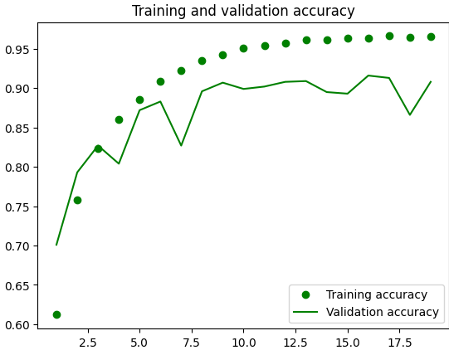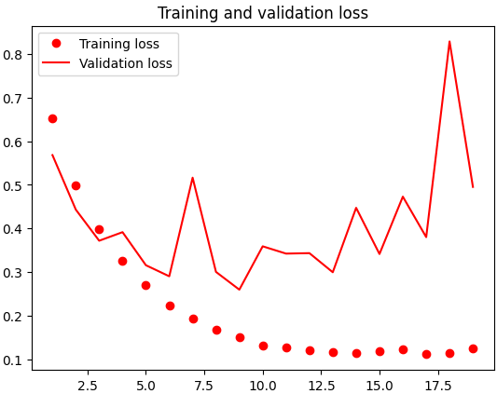

*Test accuracy = 96%*

Here we are leveraging a pre-trained convolutional neural network to extract key characteristics from input pictures while freezing the weights of the convolutional base is what feature extraction with augmentation by freezing on convolution base is all about. This method allows for effective and powerful transfer learning since the extracted features may be utilized to train a new classification model with ameliorated data.

1. Pre-Trained samples increased and tested

|  |  |  |  |  |
| --- | --- | --- | --- | --- |
| Implementations | Loss | Accuracy | Validation_L | Validation_A |
| Samples to 10,000 | 09 | 98 | 49 | 95 |
| Fine tuning 8000 | 06 | 97 | 14 | 97 |
| Samples to 18000 | 07 | 97 | 20 | 97 |

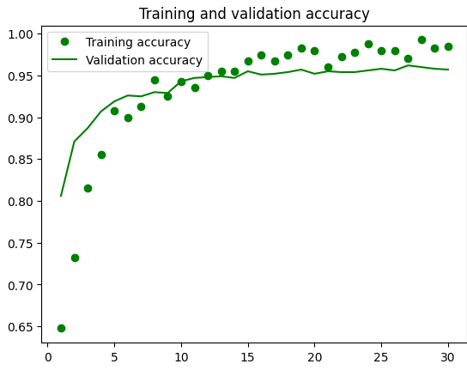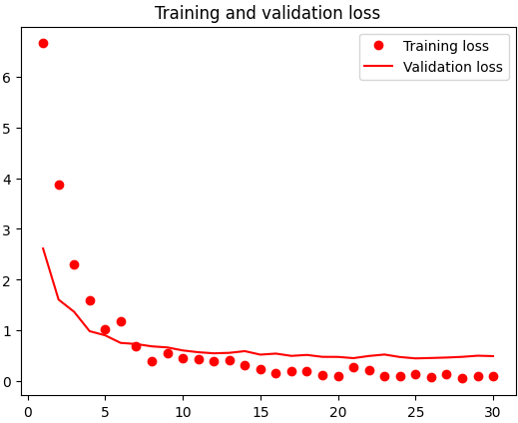

*Test accuracy =* ***98%***

Fine tuning is a viable option when the new work is comparable to the initial task and adequate data is available, but feature extraction is simpler when the current assignment has an inadequate amount of categorized information. However, in some circumstances, combining both strategies may yield the greatest results.

Overall we can observe that the accuracy of the test is better obtained when the optimization is used with regularization techniques and higher sample rate.

Citations:

1. [Analytics Vidhya](https://www.analyticsvidhya.com/blog/2021/05/convolutional-neural-networks-cnn/#:~:text=In%20deep%20learning%2C%20a%20convolutional%20neural%20network%20%28CNN%2FConvNet%29,ConvNet.%20It%20uses%20a%20special%20technique%20called%20Co)
2. [Machine learning mastery](https://machinelearningmastery.com/convolutional-layers-for-deep-learning-neural-networks/)
3. [Code provided on github](https://colab.research.google.com/github/fchollet/deep-learning-with-python-notebooks/blob/master/chapter08_intro-to-dl-for-computer-vision.ipynb#scrollTo=Cky34O3LkRER)